1. Go to www.spellingcity.com

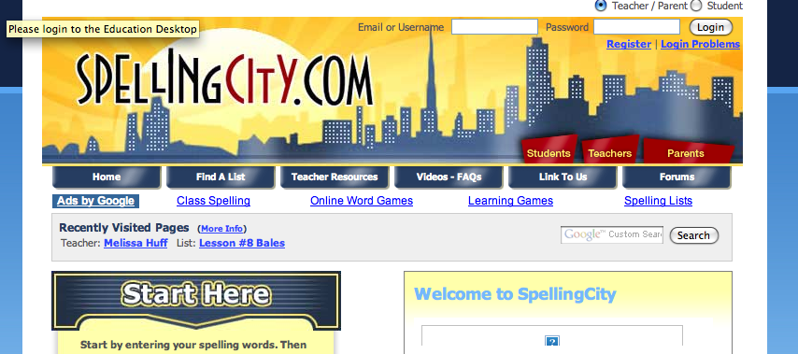

2. Click on Find A List tab.

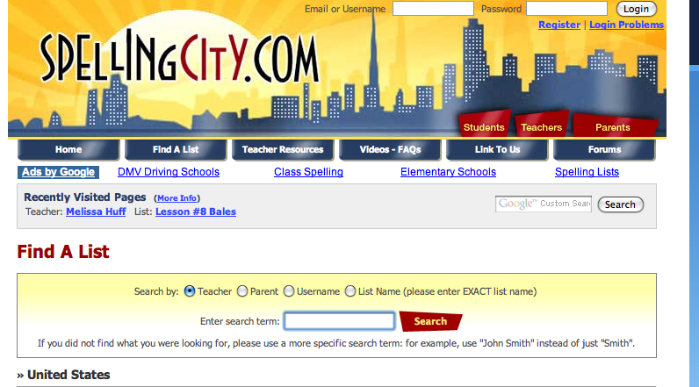

3. Type in Melissa Huff in the Search term
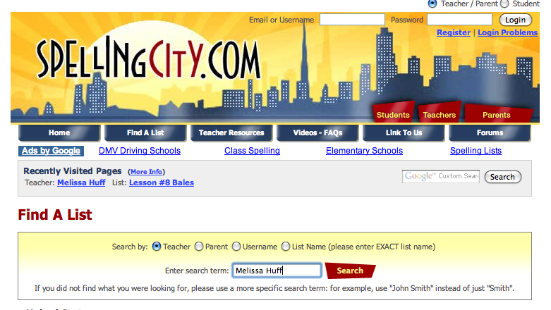

5. Click on Melissa Huff under the search results.

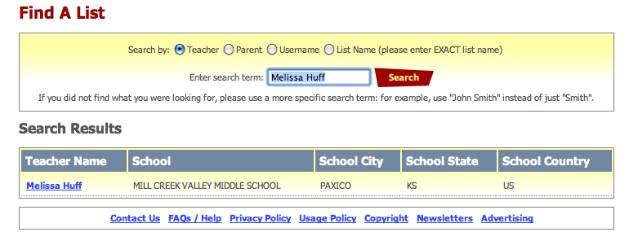

6. Click on your spelling lesson for the week. You may do teach/test or games.
